Name Date Stone/Fanelli

Enzyme POGIL

ESSENTIAL QUESTION: How does an enzyme influence chemical reactions?

- 650 m
B. 1400 m
Figure 1

Introductory Situation Questions:
- If you’re going hiking this weekend and you have the option of hiking a mountain that is 1400 meters in height and a mountain that is 650 meters in height, BUT you know that you have limited time because of other plans – which mountain would you choose to hike, A or B? EXPLAIN WHY.

- If you’re hiking at the same pace, which of these mountains would require MORE energy to hike up (A or B)?

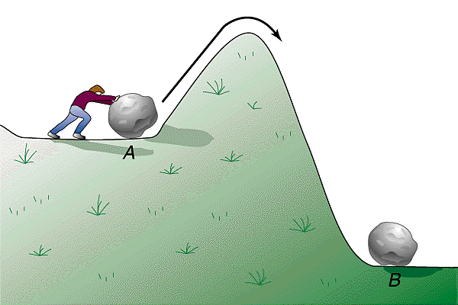
Information Section 1: Activation Energy
Figure 2
The picture to the right shows someone trying to push a boulder up a hill. In order for the boulder to reach its final destination at point B, it must be pushed to the top of the hill because once it reaches the top of the hill it will roll down the rest of the way. A similar scenario exists in chemistry, before a chemical reaction will take place, energy must be put into the system. The energy needed for a chemical reaction to move from point A to the top of the hill is known as activation energy, also written as E_{a.}

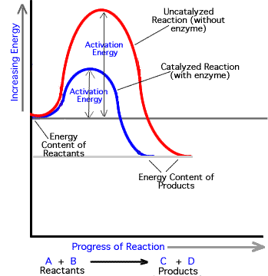
Figure 3

(TIME)

- Compare Figure 3 above to the Figure 1 (comparing the heights of 2 mountains), determine how using an enzyme in a chemical reaction impacts the reaction by answering these questions.

- Does it speed up or slow down the reaction? __________________
As see in the graph
- What does the enzyme do to activation energy?

- Based on your answers to questions a and b, what do you think the term “catalyzed” means?

Information Section 2: Lock and Key Theory
Figure 4
- Answer the following questions to determine what you know about keys.

- What are the characteristics that distinguish one key from another?

- Where are some places that you use keys?

- Can a key from one place open the lock of a different key?

- If you had to choose from the word “specific” or “general” to describe a key, which would you choose? ____________________

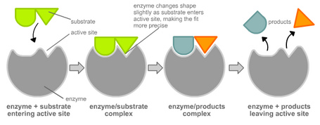
Figure 5

- Looking at Figure 5 above, how is the enzyme similar to a lock and a key?

- Complete the following analogy using the terms show in figure 5 (Enzyme and Substrate).
Lock : Key :: ______________ : _______________

- If the substrate in the first image in the left of the series is a disaccharide such as sucrose, what is the enzyme doing to the disaccharide?

- The picture above is showing what is known in biochemistry as the “lock and key theory.” Explain why you think this theory is used to describe enzymes.

- What are some examples from biology/chemistry class or from other areas of your life where the specific shape of something is important for it to work correctly?
Information Section 4: Shape Changes
Image A: Before

Image B: After

The other day I was really excited about my new coloring book, so I bought a new pack of Crayola crayons and forgot that I left them in my pocket. When I went to do my laundry later in the week, you can see what happened to the stack of crayons after they were put through the dryer.
- How would you describe what happened to my crayons between image A to image B?

- Will I be able to accurately color my coloring book if the crayons are like this? Explain.

- What caused my crayons to be changed?

- What are some other things that you have seen “melted” or change shape which impacted their ability to work correctly. Come up with at least 3 other examples.

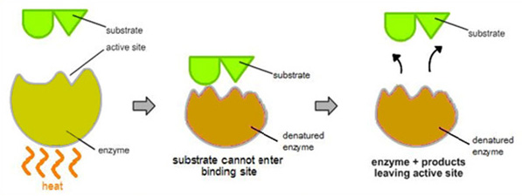
Figure 6

- Figure 6 above shows what happens to an enzyme when exposed to heat. How is this similar to what happened to my crayons?

- What term is used to describe when the shape of the enzyme has been altered? (Look at the figure in the middle!)

- Can you predict other things that may influence the activity of enzymes in a positive or negative way?

Information Section 5: Factors Affecting Enzyme Rate
You now know that enzymes have a very specific shape and they must retain their shape in order to function properly. There are many factors that can change the shape of an enzyme and/or change the rate at which it works. Concentration of enzyme or substrate, temperature and pH are just a few factors that have the potential to change the rate of a chemical reaction.

- With the knowledge that a lot of enzymes work within the human body, hypothesize what temperature and pH might be optimal for enzymes to work properly.

Analyze the experiment below to determine the effects of temperature and pH on enzymatic activity.
H₂O₂ is produced as a byproduct of many metabolic processes, but it is toxic to most living organisms. Many organisms are capable of enzymatically destroying the H₂O₂ before it can do much damage. H₂O₂ can be converted to oxygen and water, as follows:
2 H₂O₂ 2 H₂O + O₂
Although this reaction occurs spontaneously, enzymes increase the rate considerably. At least two different enzymes are known to catalyze this reaction: catalase, found in animals and protists, and peroxidase, found in plants. A great deal can be learned about enzymes by studying the rates of enzyme-catalyzed reactions.

Use the data collected from the experiment (shown below) to construct graphs of the effects of several variables on the rate of the enzymatic catalysis of hydrogen peroxide.
Experiment #1: The Effect of Concentration on Reaction Rate |  |  | Experiment #2: The Effect of pH on Reaction Rate |  |  | Experiment #3: The Effect of Temperature on Reaction Rate
Number of Drops of Enzyme | Reaction Rate  (kPa/min) |  | pH of Solution | Reaction Rate  (kPa/min) |  | Temperature | Reaction Rate  (kPa/min)
2 | 0.27 |  | 4 | 0.36 |  | 10˚C | 0.58
4 | 0.73 |  | 7 | 0.97 |  | 35˚C | 1.43
6 | 1.29 |  | 10 | 0.89 |  | 55˚C | 0.36

- What type of relationship exists between substrate concentration and reaction rate? Could you explain why you think this relationship exists?

- Predict what would happen if you added 20 drops of enzyme to the test tube.

- What is the optimal pH for catalase? Why do you think it becomes less effective at high or low pH?

- Can you think of anywhere in the human body where enzymes would work BEST at a high pH? Please give an example and draw what that graph might look like.

- What is the optimal temperature for catalase? Why do you think it becomes less effective at high or low temperatures?

- Can you think of any organisms that would have enzymes specifically adapted to extreme low or high temperatures and would therefore function best at a different part of the graph? Please give an example and draw what that graph might look like.

Information Section 6: Enzyme Uses
Enzymes are complex proteins produced by all living thing. Enzymes are substances that help carry out a number of the body's function like transforming food and chemical elements into other needed substances. Enzymes help eliminate toxins in the colon, kidneys, liver, lungs and skin.
Like all proteins, enzymes consist of chains of amino acids linked together. The amino acids within each kind of enzyme have a characteristic arrangement. The bonds between the different amino acids in the chains are weak and may be broken by such conditions as high temperature or changes in pH. When the bonds are broken, the enzymes become non-functional; sometimes this results from diseases.

The most well known and important enzymes are the digestive enzymes:
- Amylase - contained in saliva. Splits the carbohydrates in order to be assimilated by the intestine.
- Protease - contained in the gastric juices. Splits proteins so they can be digested.
- Lipase - secreted by the pancreas. Split fats into fatty acids so that it can be digested.
- What are some uses for enzymes?

- Can you think of things that enzymes would be used for in living things that are not listed in the examples above?

Extension Questions (http://www.scribd.com/doc/20814723/Ch6-Application-Questions)
- Amylase is a digestive enzyme that breaks down starch and is secreted in the mouth of humans. Amylase functions well in the mouth but ceases to function once it hits the acidic stomach environment. Explain why amylase does not function in the stomach.

- You are studying a new species never before studied. It lives in acidic pools in volcanic craters where temperatures reach 100°C. You determine that it has a surface enzyme that catalyzes a reaction
leading to its protective coating. You decide to study this enzyme in the laboratory. Under what conditions
would you most likely find optimum activity of this enzyme? Explain your answer.

- Low grade fevers are healthy because they help our body get rid of harmful bacteria/viruses, but when fevers reach of temperature of 105˚ Fahrenheit it is extremely dangerous. Using your knowledge of enzymes explain why. (Note: be sure to use the scientific terms throughout to help explain what happens!)

Wrap-Up/Conclusion
Do you feel you understand the role of enzymes in living things and how they work? What questions do you still have about enzymes?

